PDC Lab 5 Report
Advait Deochakke
20BCE1143

Example program with x=x+thread_id for critical, single and master. To prove concept, use one shared variable for each synchronization construct.

1) Example Program - Critical

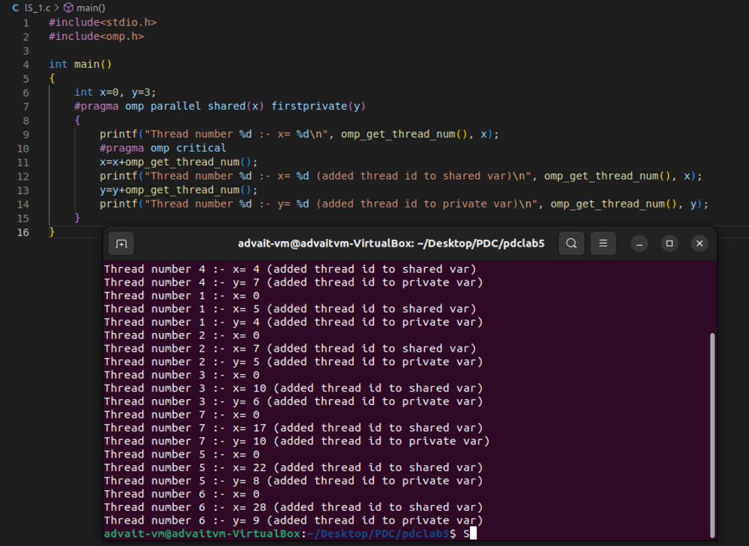

2) Example Program - Single

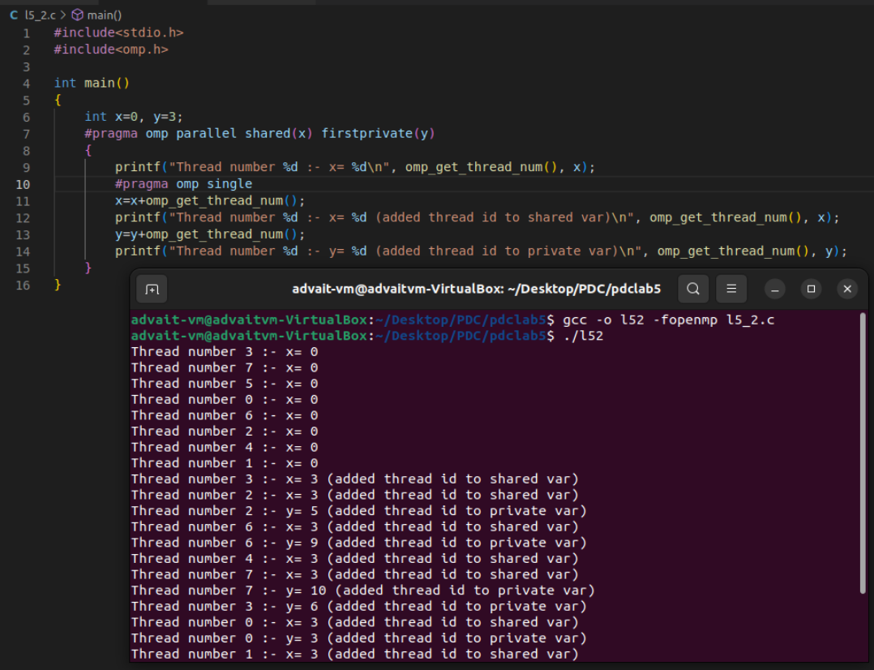

3) Example Program - Master

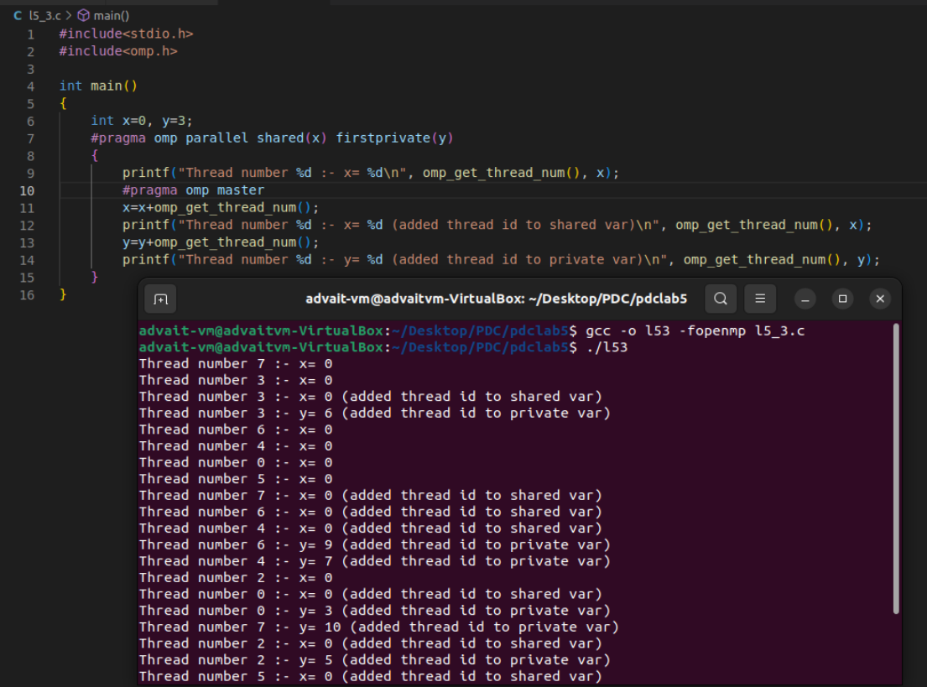

VIT placement cell where 100 students are placed in 4 companies. Get as input the name, register number, the pay package of students selected for jobs in the particular organization
Display the total number of students selected in each company.
Display the average pay package of the 100 students.

